D:\SELECT 19\Udemy - Adobe Premiere Pro CC-Learn Video Editing In Premiere Pro

# Chapter 1 : Introduction to Premiere pro

001 Course Introduction.mp4–

Instructors Name is Will Barlet

003 Starting A New Premiere Pro Project.mp4

Creating a New Project.

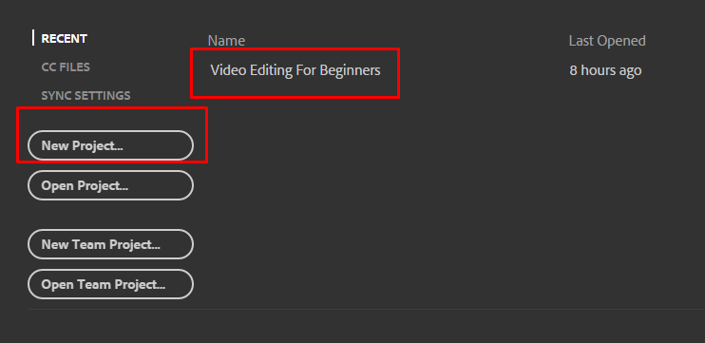

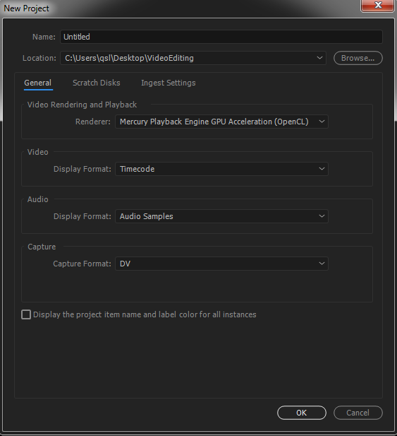

004 Introduction To Premiere Pro Panels.mp4

005 Workspaces.mp4

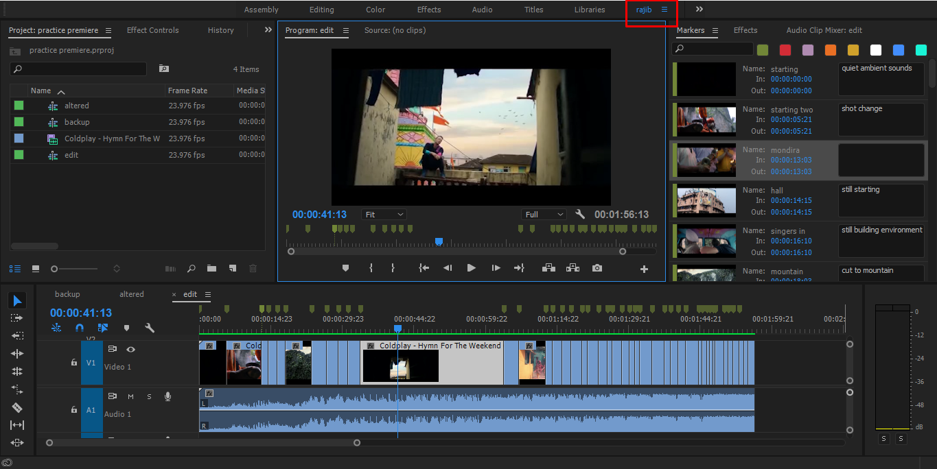

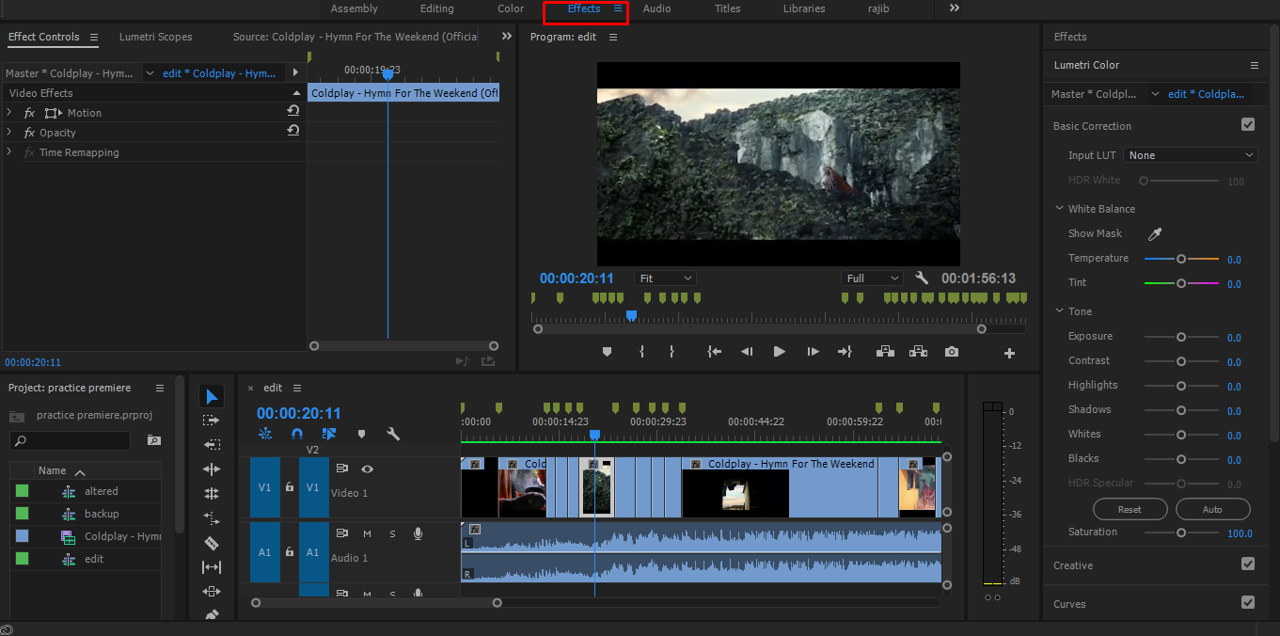

006 Optimizing Premiere Pro.mp4"

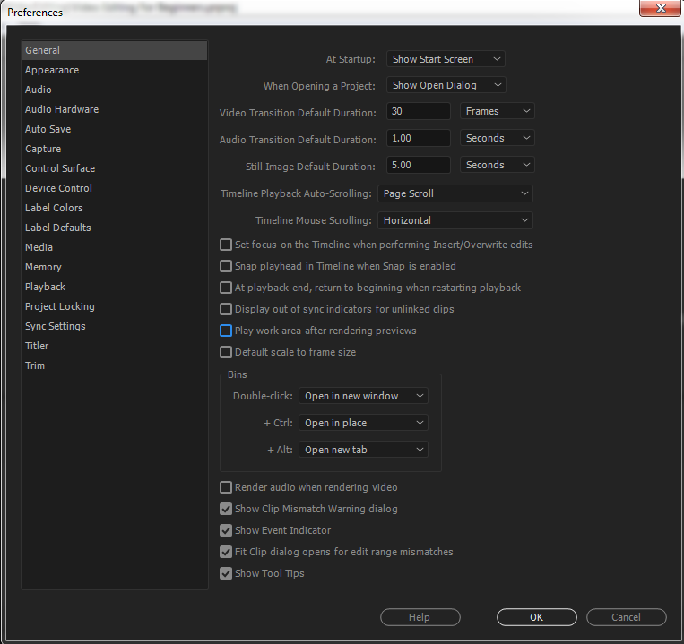

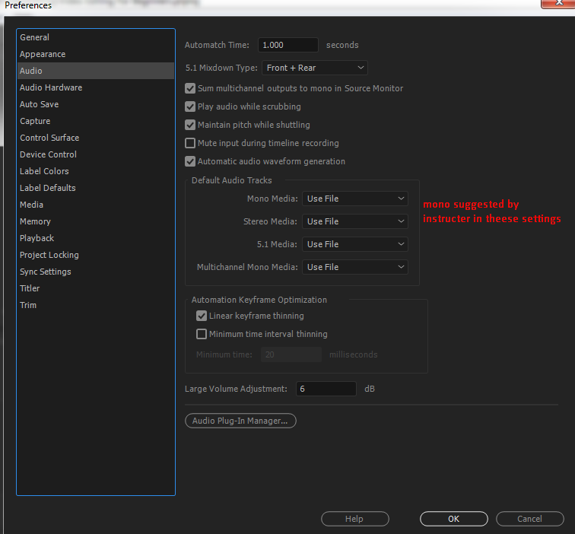

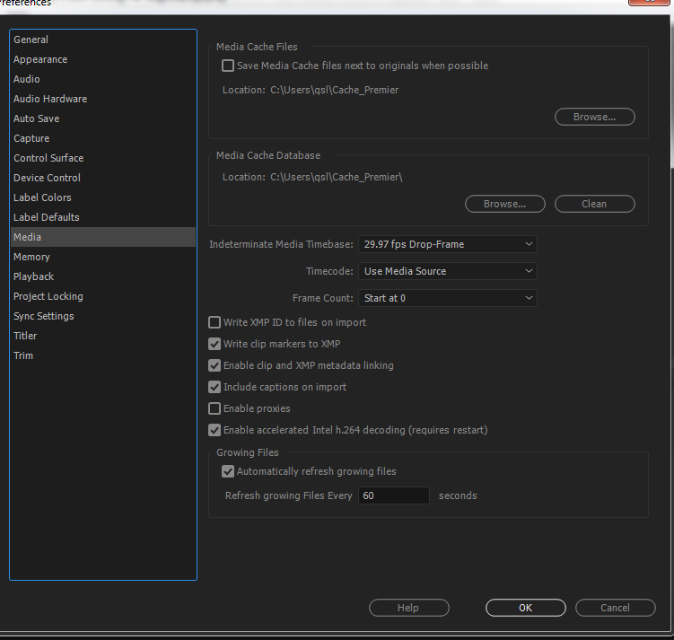

# Chapter Two : Intro to Video Editing

008 Backing Up Footage.mp4

Very Important – always keep back up in atleast two different hard drives.

009 Hard Drive Folder Structure.mp4

010 Understanding Resolutions.mp4

## 011 What is a sequence_.mp4"

File > New > Sequence   
or ctrl + n   
will create a new sequence

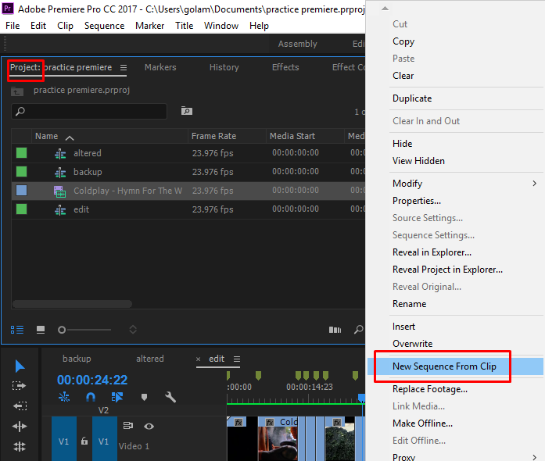

012 Creating Sequence Presets.mp4"

Creating new sequence preset > skipping it now.

## 013 Importing Content and Premiere Pro Folder Structure.mp4

File > import or ctl+i

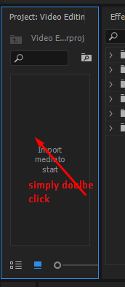

## Bin

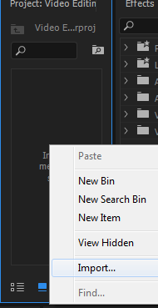

Bin is like folder

You can drag and drop for importing.

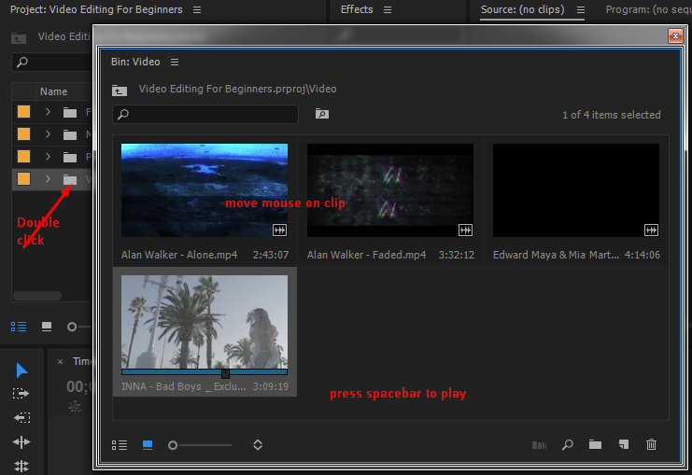

Its a good strategy to have all the required footage folders inside one folder per project. And organizing contents within folder helps.

## 014 Adding Clips To A Sequence.mp4

Simply Drag and drop from project panel will work.

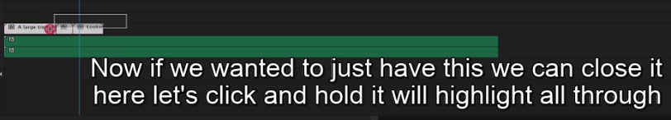

## 015 Track Layers.mp4

The top layer is the layer that is seen.

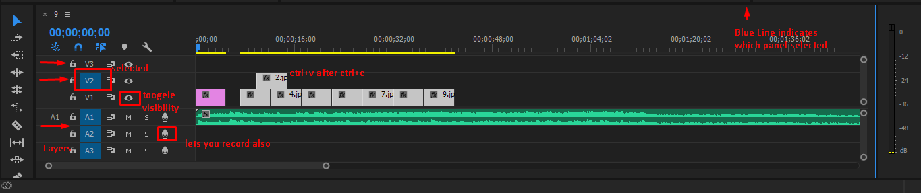

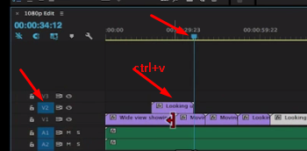

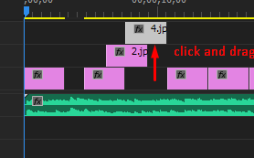 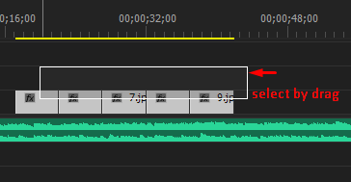

## 016 Introduction To Working With Audio.mp4

Any audio clip that is present will be heard unless muted.

017 Playback Quality.mp4

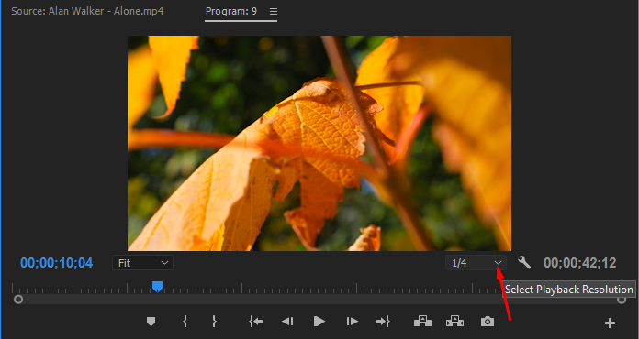

## previous Learnings

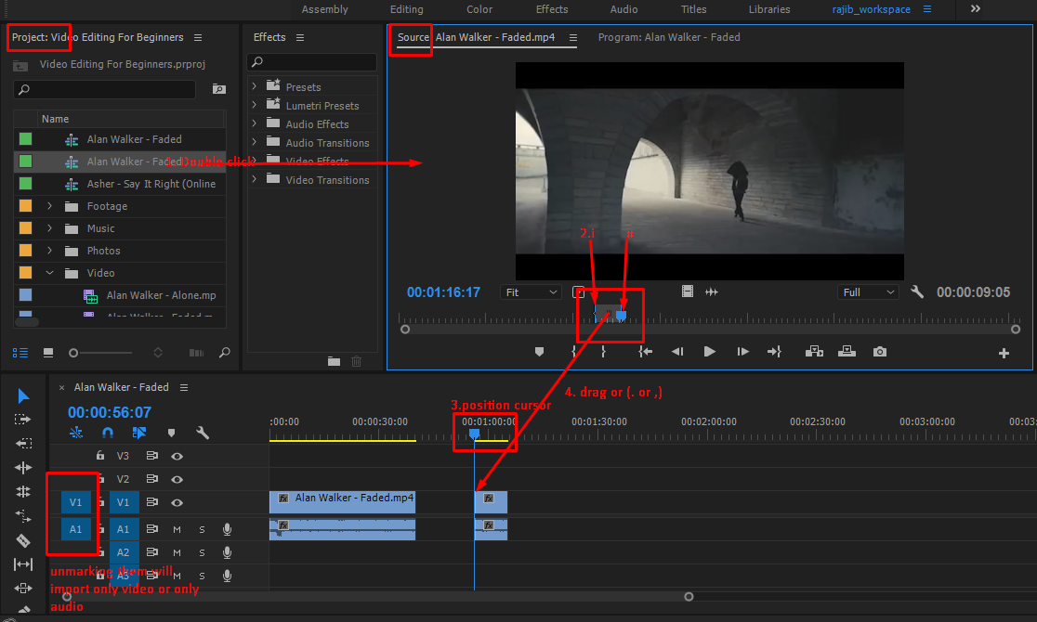

→ moves one frame

↓↑goes to end of cut or beginning of cut

J or L - moves backward or forward_real time j – multiple times fast forward or backwar

K pauses , (j Or L ) with K – slow motion forward or back ward.

Space – plays

I – selects in points , O – selects out point , shift+I or O – goes to in or out point.

~ - enlarges the panel.

alt + backspace – ripple delete

alt+clt+drag clip in time line – shifts position without over riding

alt+drag in timeline – duplicates a clip

## 018 Picking Selects.mp4

Create new sequence named ‘edits’ ctrl+n enter > create new sequence named final > cut in edit sequence with razor tool (c) > **take only the good one** - copy (ctrl+c) from ‘edits’ sequence ,paste to ‘final’ sequence. [This can also be done by – mark in (i) > mark out(o) , ctrl+c , ctrl +v at desired position.]

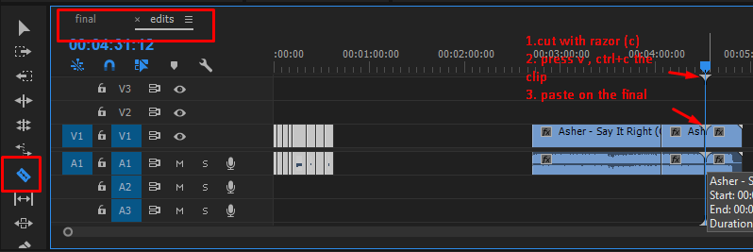

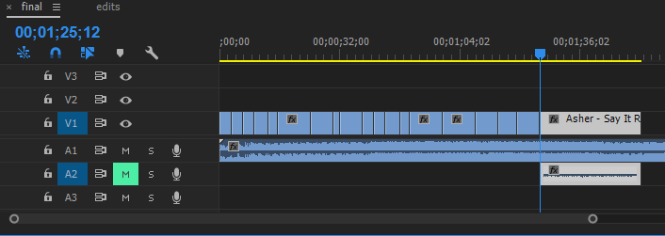

## 019 Source Panel Window.mp4

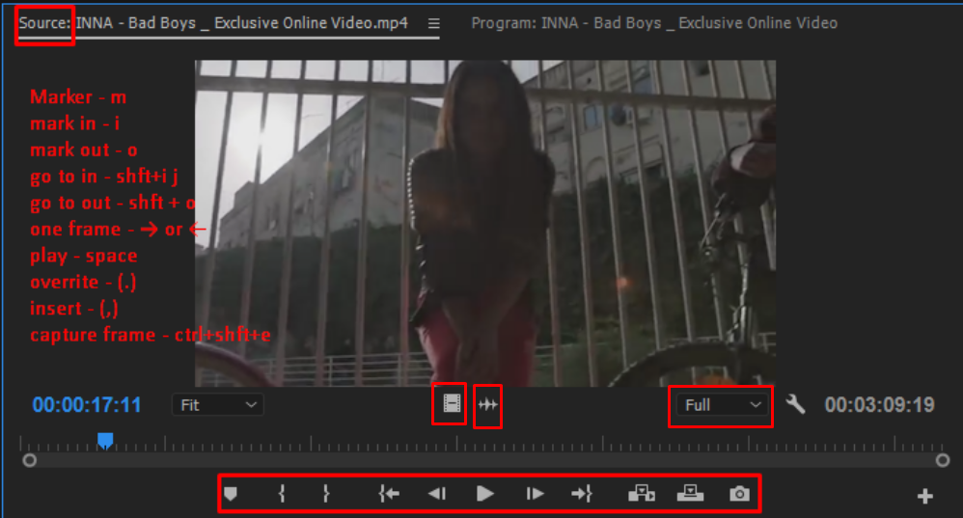

This is just another way of editing. Instructor prefers the cutting method discussed earlier.

## 020 Moving Clips And Trimming.mp4

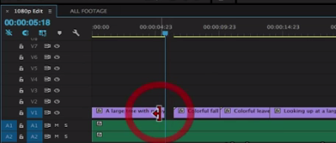

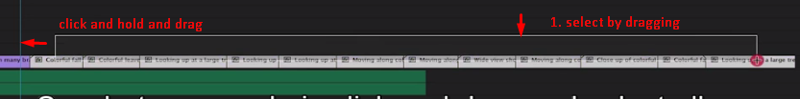

## 021 Editing To Music Using Markers.mp4

pressing + or - zoom in / out the time line

Pressing M marks

Selecting audio and pressing m – marks audio

#### Pressing ‘s’ activates snaps

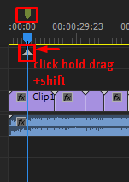

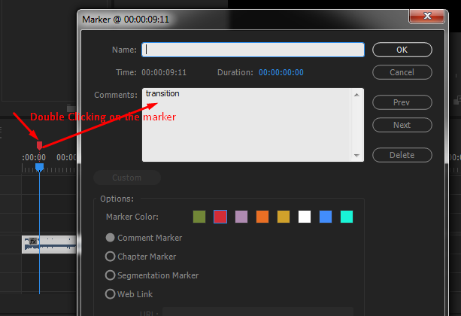

Or doulbe press ‘m’

#### Clear markers

on selected audio file > double click the audio > it will open source > from source > clear all markers by right clicking on source.

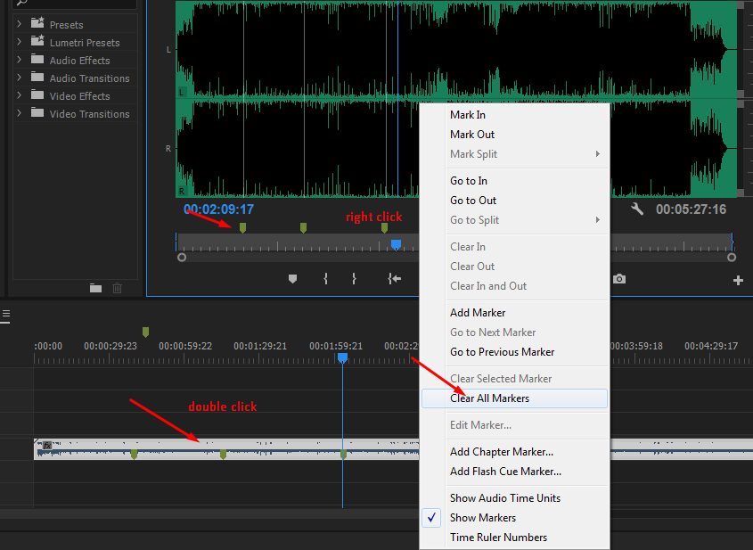

## Marker

Shift + m goes to next marking place, ctl+shift+m goes to previous marking place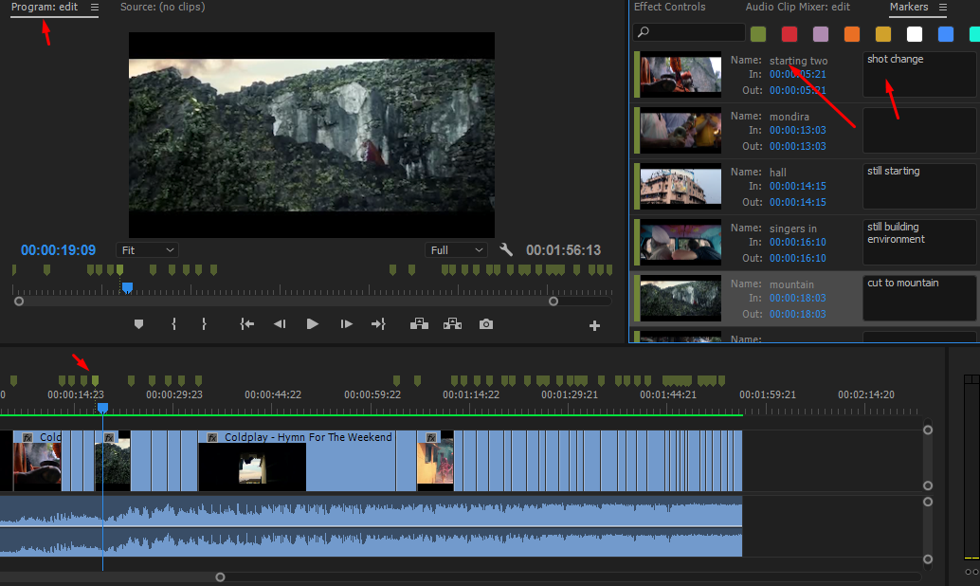

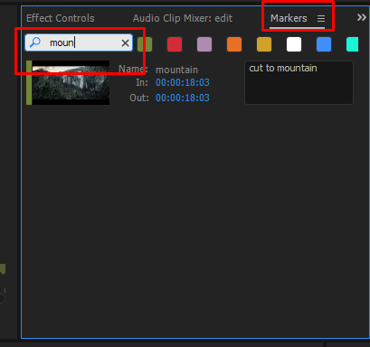

You can mark audio, source or sequence.

022 Checking In.mp4 ← just add about udemy

# EFFECTS

## 023 Effect Controls.mp4

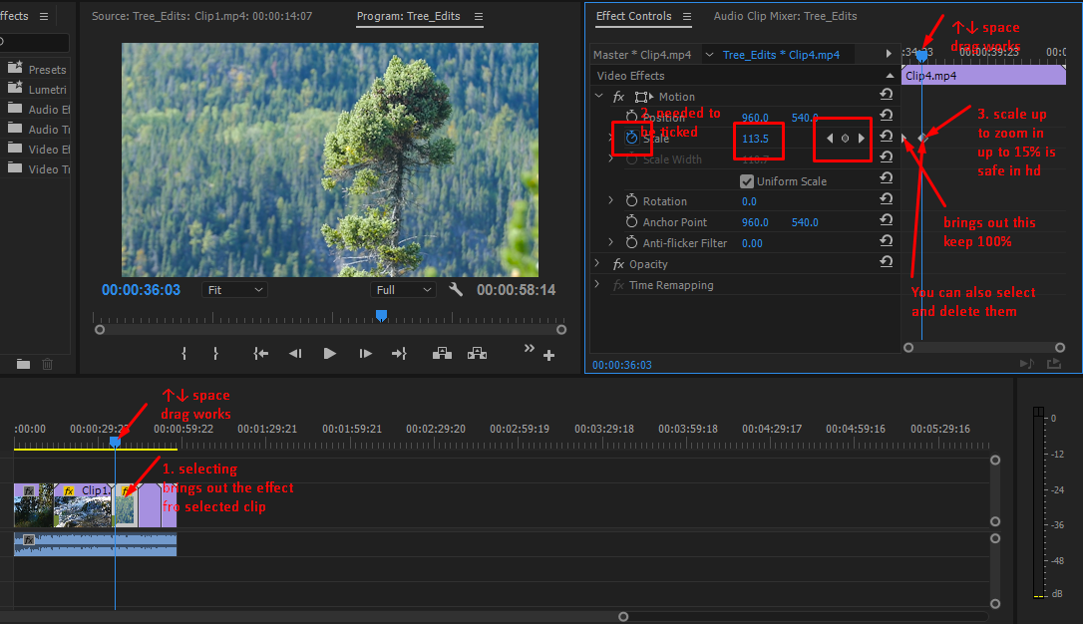

## 024 Rate Stretch.mp4

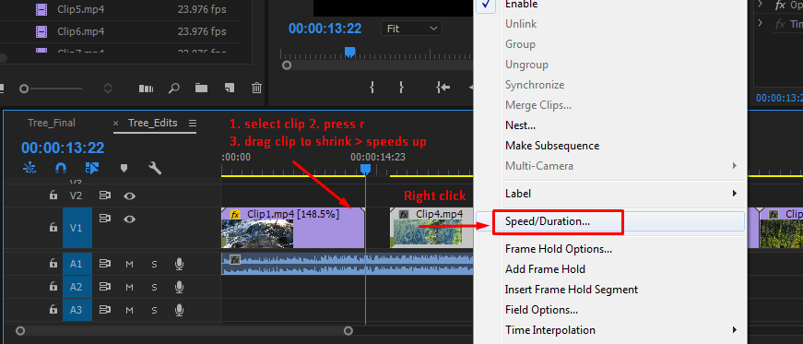

ctl+r

## 025 Transitions.mp4

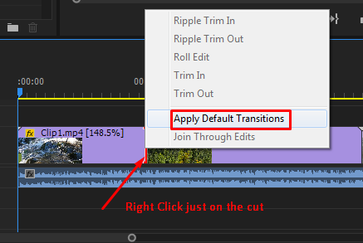

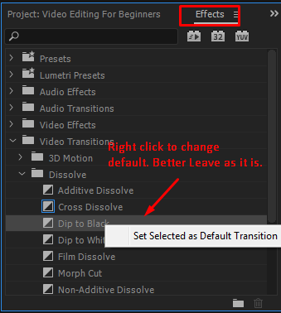

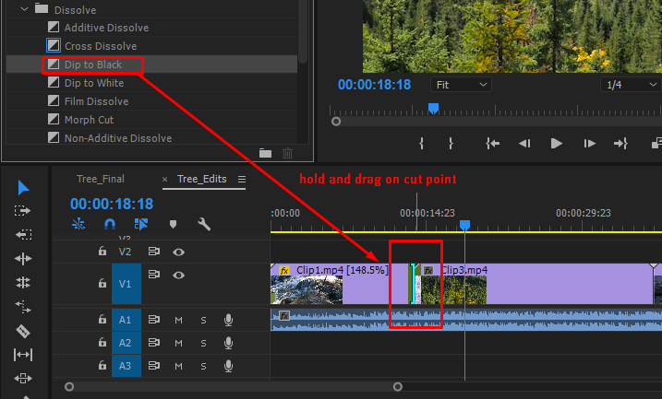

Explore Different Transitions ☺

## 026 Rendering Previews.mp4

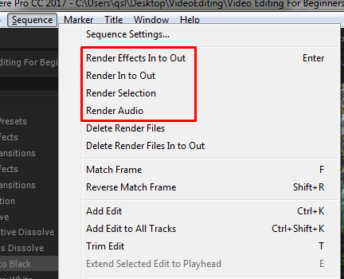

## 027 Creating Text Titles.mp4

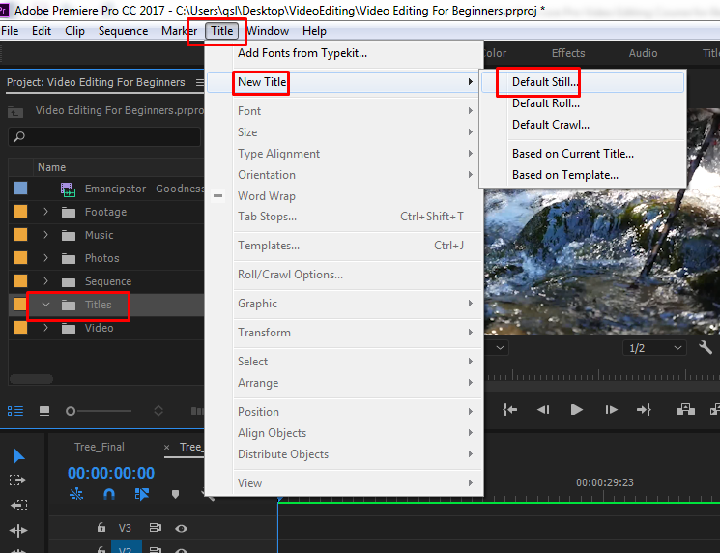

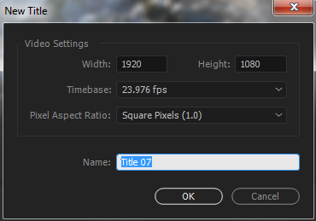

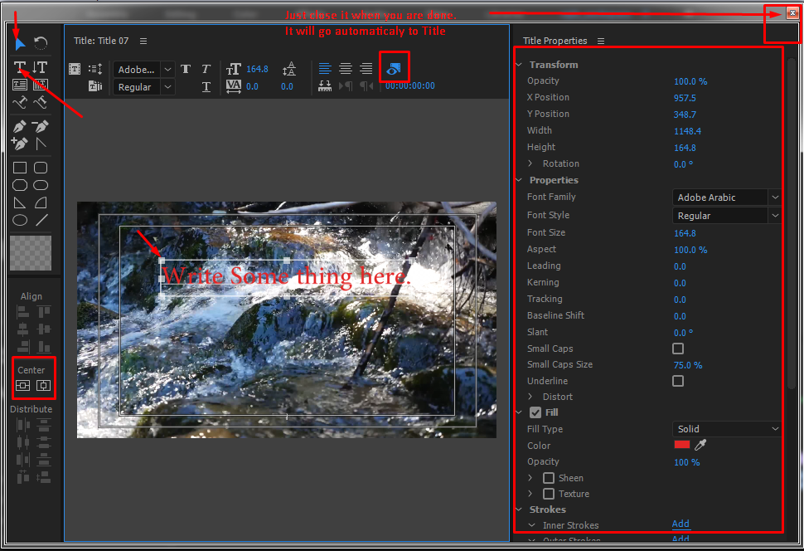

028 Working With Titles In Your Sequence.mp4

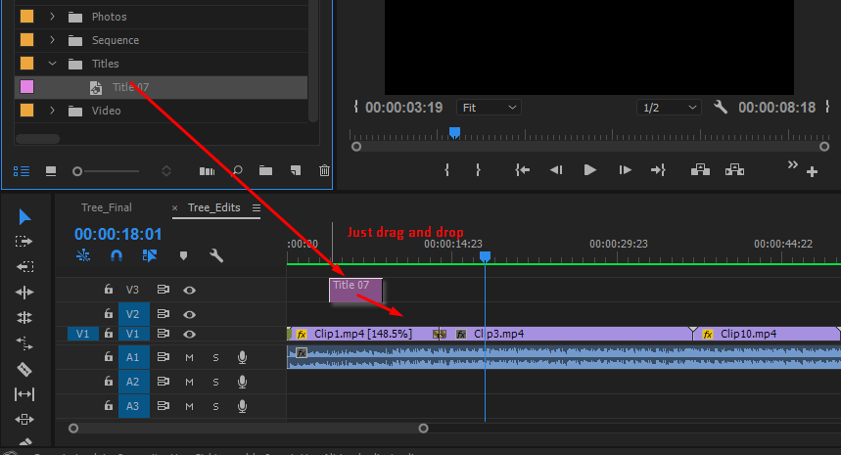

[applying transition on titles – skipped]

029 Color Mattes.mp4

[skipped]

# Working With Audio

## 030 Audio Keyframes.mp4

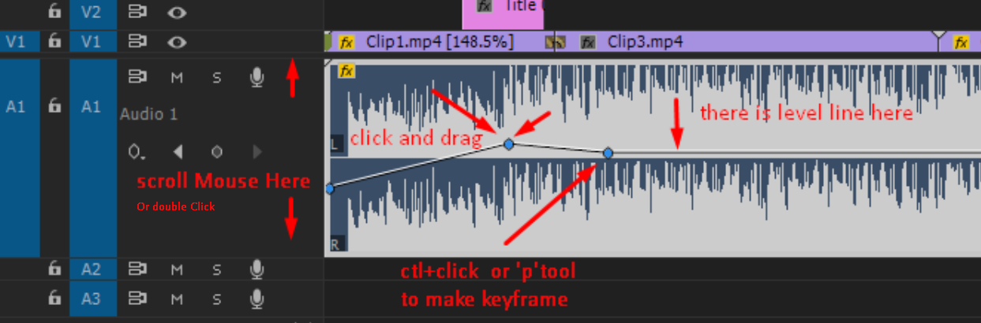

## 031 Dipping Audio For Dialogue.mp4

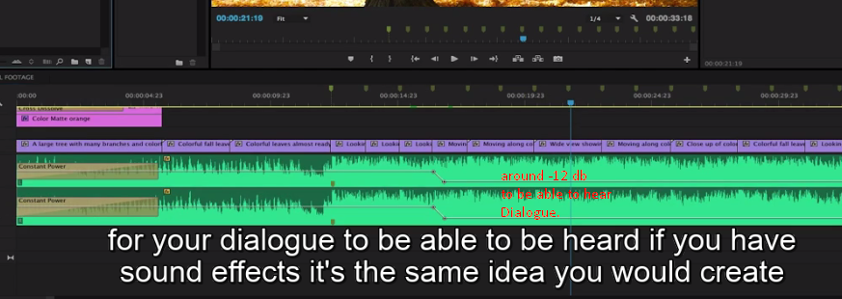

## 032 Audio Track Mixer.mp4

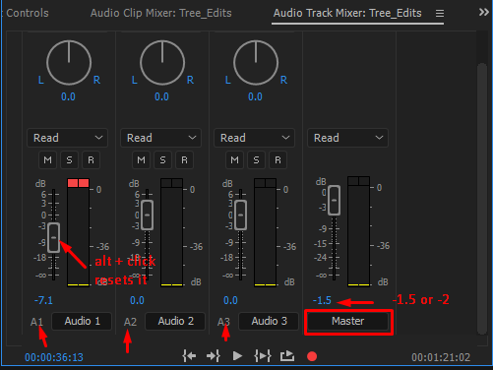

033 Audio Plugins In Premiere Pro.mp4

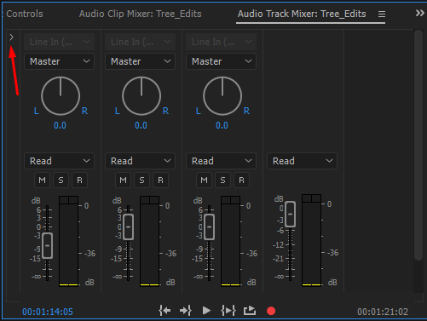

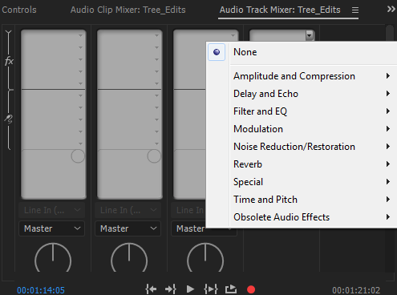

Higher level things for me ☹

# INTERMEDIATE EDITING

034 Color Labels.mp4

Understood. Practice when required or later.

035 Nesting.mp4

Understood. Practice when required or later.

036 Lower Third Titles.mp4

Understood. Practice when required or later. [showing name of the person with animation]

## 037 Frame Hold.mp4

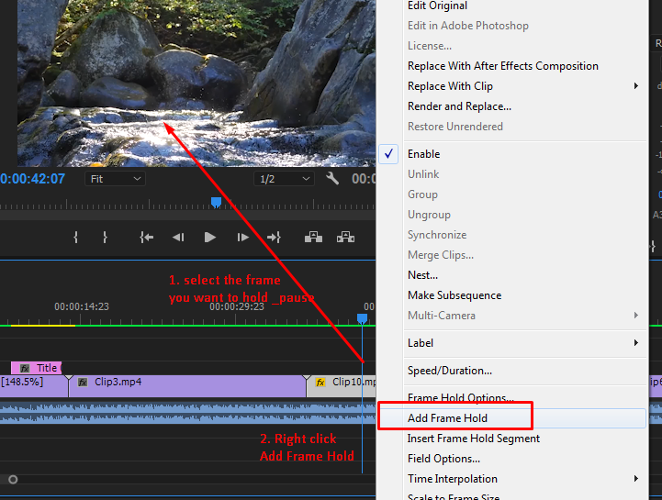

KEY BOARD SHORTCUTS

## 038 Keyboard Shortcuts And Tools.mp4

ctl+a, ctl+c, ctl+v, 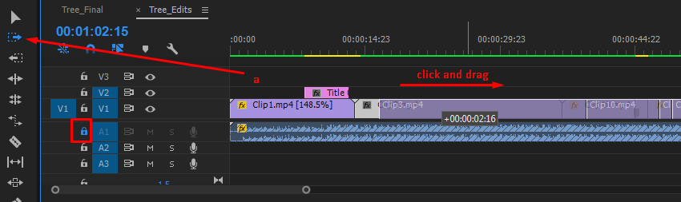

a, or shift+a ,

alt+backspace – ripple deletes,

alt+ctl drag – shifts clip[ clip 3 goes to clip 4, clip 4 comes to clip 3]

b or ripping edit (nice) - shrinks clip 3 and all other clips follows (or shift back to original length)

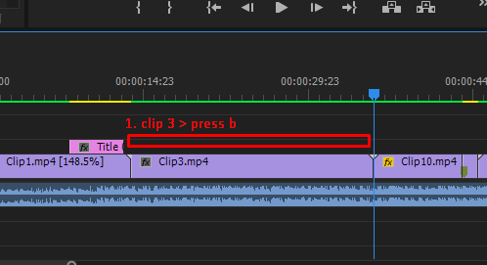

See Next Picture

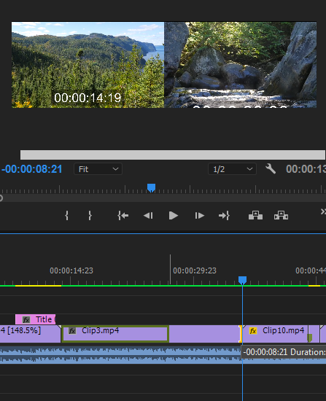 Just click and drag

Result > 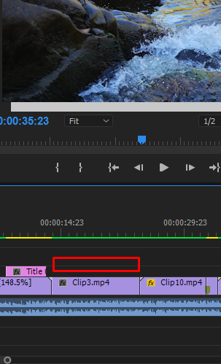

# COLOR CORRECTIONS

039 Color Correction Basics.mp4

040 Color Grading Basics.mp4

041 Final Touches To Your Edit.mp4

## 042 In And Out Points And Exporting Media.mp4

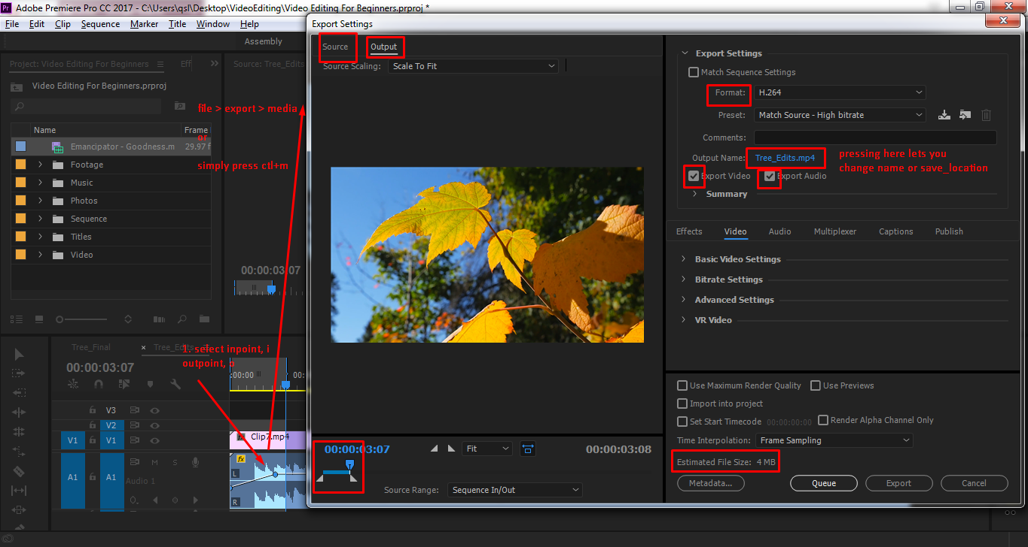

043 Creating Export Presets.mp4

If needed to create presets visit back and create by watching.

044 Batch Exporting.mp4

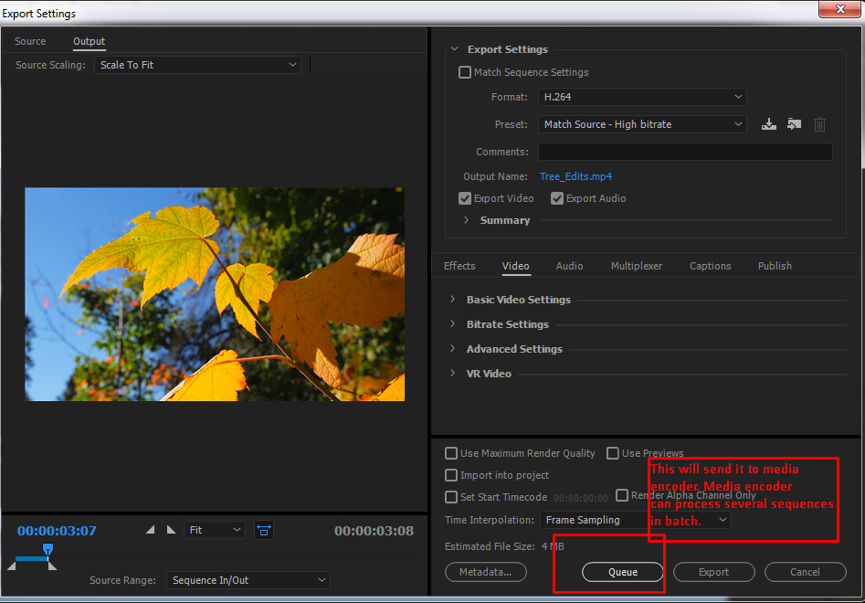

045 Create A Client Reference Preset.mp4

Interesting. See it when actualy exporting file.

046 Final Thoughts.mp4

Ctl+k